Top 40 Games – Web App

Aim/ Project Proposal
The aim of this project is to design a website/ web app using the Django full-stack framework to compare sales data from popular video games on various platforms between the years of 1980 to 2016.
The video game sales data used on the web app has been obtained from the data set “video_games_sales.csv” vreated by the kaggle user Ulrik Thyge Pedersen which can be found at: https://www.kaggle.com/datasets/ulrikthygepedersen/video-games-sales

The dataset is a robust collection of physical sales data for over 15,000 video game titles which categorises each game by year of release, global, North America, Europe and Japanese sales. This set is by no means a comprehensive list of every video game sale, however it provides a great reference to compare popular titles.

The primary aim of the site “Top 40 Games” is to present a “top 40” list of video games by (1) decade (80s, 90s, 00s and 10s), (2) video game console (including Xbox, Playstation and various Nintendo systems), (3) The total unit sales between the years 1980 and 2010 that shows the growth of the industry over three decades, (4) allow the user to search for top 40 sales by year (between 1980 and 2016) and (5) display the top 100 best selling titles of all time.

Method
As mentioned, the application will employ the use of Django to provide the requested data to the user. Each page of the application will use the below pseudo-code.

Pseudo-code for each page

ACCESS webpage
user selects the data that they want to see
Click a button with requested DATA
SEND request to the BACK-END
QUERY the Database for requested DATA
PREPARE a Bar chart of Game Titles by Game Sales
Use the PLOTLY Module BAR function
DISPLAY the DATA on the webpage by highest selling
USE Javascript to order the data in decending order
DISPLAY the Bar Chart
embed the PLOTLY chart in HTML Document
The user can select another filter for the data
OR
The user can visit another page

The web app also offers the option to display total unit sales as a scatter plot of Year vs. Unit sales. The algorithm to obtain the complete sales of each year is described with the Pseudo-code below:

Pseudo-code for scatter plot generation

QUERY the Database for every entity (GAME)
CREATE an ordered list of YEARS from 1980 to 2010
each entity of the YEARS list has attribute for NA sales, EU sales, JP sales, Other Sales and Global sales
all set to zero.
Each GAME has its sales added to the YEARS list attributes for their corresponding year
5 Scatter Plots are constructed using the YEARS dataset
The PLOTLY Module SCATTER function is used to plot year vs. total game sales in each year
the 5 scatter plots correspond to NA, EU, JP, Other and Global sales.
DISPLAY the 5 Scatter plots to the user

Reflection
The biggest challenge with this project was finding a dataset to use. My interest with video games eventually narrowed the search down to the current dataset. I have previous experience with the Django framework, Javascript, CSS and HTML so this project was an opportunity to build something that builds on my strengths. The Plotly module is a powerful tool for Data visualisation with a number of standardised graphing tools. The most interesting challenge was transferring the data within the csv file to the SQLite database that Django comes packaged with. The original approach was to use the pandas module however the standard python csv module offered an option to creat terminal command that will read the file and convert it to a module. The largest task was to style the templates using CSS which was greatly rewarding as it offers more flexibility in GUI programming than tkinter. Over all I am satisfied with the project and how everything has come together.

Journal/ Error Testing
09/05/23

Virtual environment – The first requirement for django is a virtual environment that makes production of the application easier to work with.
Django project and app – The project “capstone project” and application “topTenGames” have been created and the appropriate urls.py and views.py have been calibrated to display the html “templates”
HTML Templates – the templates: “consoles.html”, “decade.html”, “index.html”, “top40.html” and “year.html” have been created and linked.

10/05/23

Dataset – the file “video_game_sales.csv” has been downloaded from kaggle.com
Management/commands/datacontrol.py – is the file that is used to create a basic command to read the csv file using the python csv module and link it to the SQLite database on the Django application.
Models – The class “Game” is created as a table in the SQLite database it contains the attributes: id, name, platform, year, genre, publisher, euSales, jpSales, otherSales, naSales and globalSales for each game entity in the csv file (and soon the data base file). The model class was migrated successfully
Command testing – Because the file is so large, there are bound to be errors so a “dummy” database model “Gaem” has been created so the database is easier to correct should incorrect data be fed across.
- The first test involved using the terminal to play around with creating dummy values for the database.
- the second test involves executing the “dataControl” command which will automatically copy the entities from the csv files to the database. There were errors as some of the csv files were added incorrectly.
Correcting the CSV file – the time consuming effort to correct in correctly entered values in the csv file was made successfully. The main error was that some of the values were skipped to the right of the cells.
Successful data transfer – the command was re-executed and all entries were successfully transferred across.

11/05/23

Views – The functions to display and handle form submissions from the templates have been created and tested by printing the data that is submitted before linking the functions to eventually displaying the requested data. Test process for getting the views working is displayed in the screen shots below.

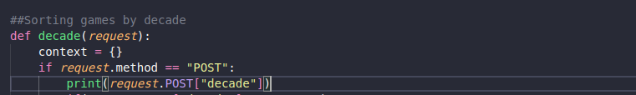
Testing the inputs that come from pressing the buttons on the “decade Page”
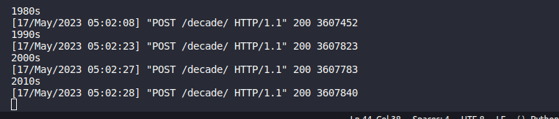
Submissions from the decades page
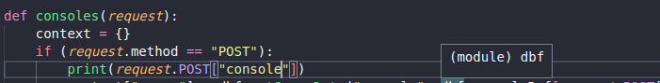
Testing the inputs for each console
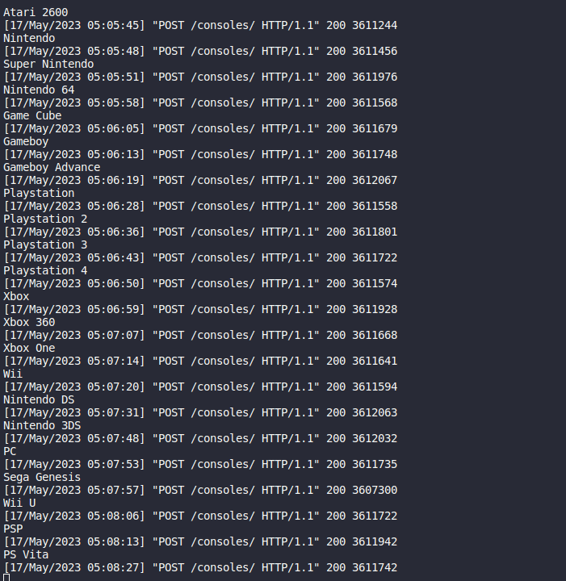
Each console button returns their correct label to the back-end

Testing the search engine for the year page – This page is the only part in the app that requires input from the user in the form of a year between 1980 and 2016 so it requires that the user enter a 4 digit integer. To test, we conduct edge cases and test that the only accepted value is of the correct type and range.

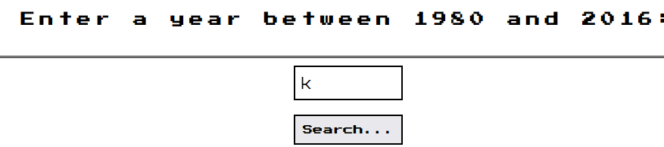
We will first test that only integers are accepted.

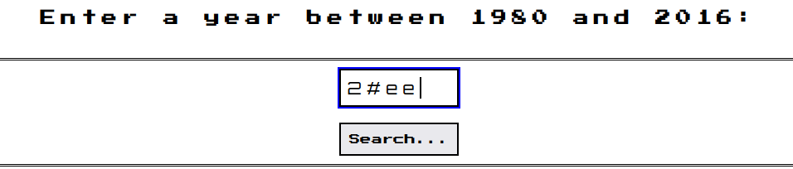
Testing if a non numeric character is accepted

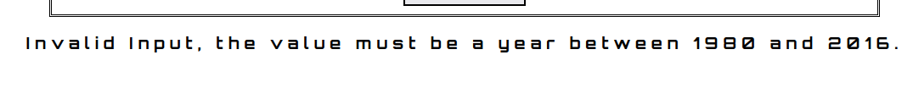
Correct response
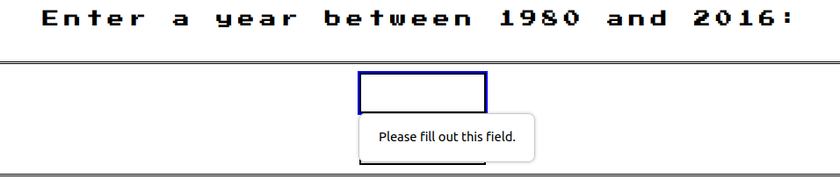
Response if no value is entered
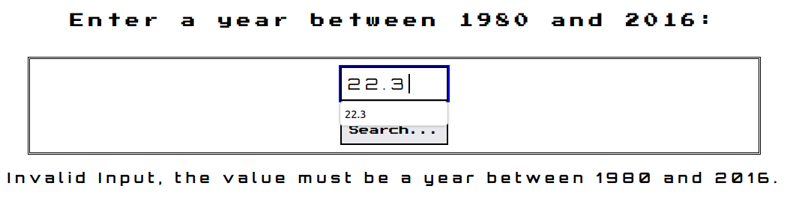
Response to entering a floating point number

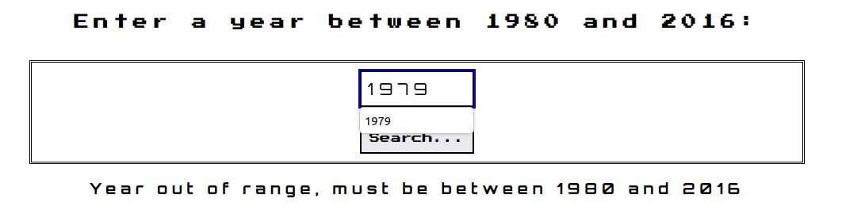
Response to placing a year value that is out of range (left side)
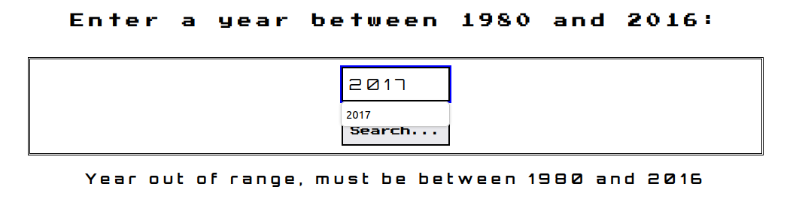
Response to placing a year value that is out of range (right side)
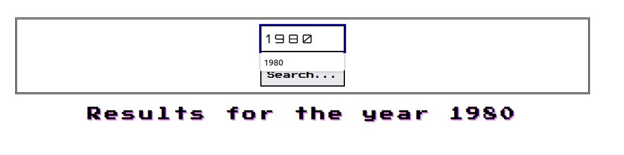
Values within the correct range are accepted (left side)
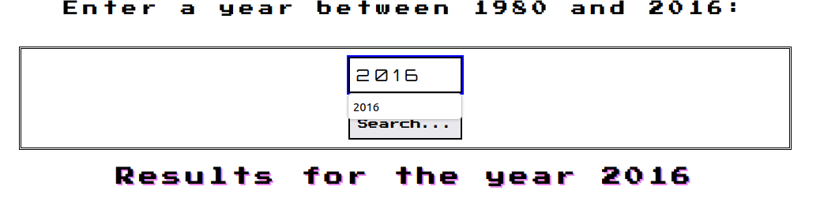
Values within the correct range are accepted (right side)

From this we can see that only the correct input is accepted. Thus the application can accept the appropriate inputs from the user.

12/05/23

dbFunctions.py – Now that the data can be accepted by the back end we must control how it is handled. The file dbFunctions.py is created to hold a dictionary that translates readable console names into their abbreviations (for querying the database) and functions that query the database and prepare the appropriate to return to the user. The function “getGamesData” takes the type (decade or console) and returns the data relating to the correct decade/ console.

Plotly graphs – the graphs corresponding to the top ten sales (game title vs. unit sales) are prepared in the views.py file and have been embedded along with their corresponding list.

Testing the responses – we are now to test if every input will return the correct values we will do this by adding a print function to return the data that has been queried and testing that each input button works.

Decades
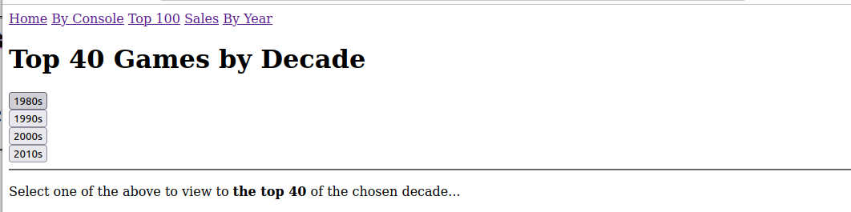
We will click each button and analyse the results

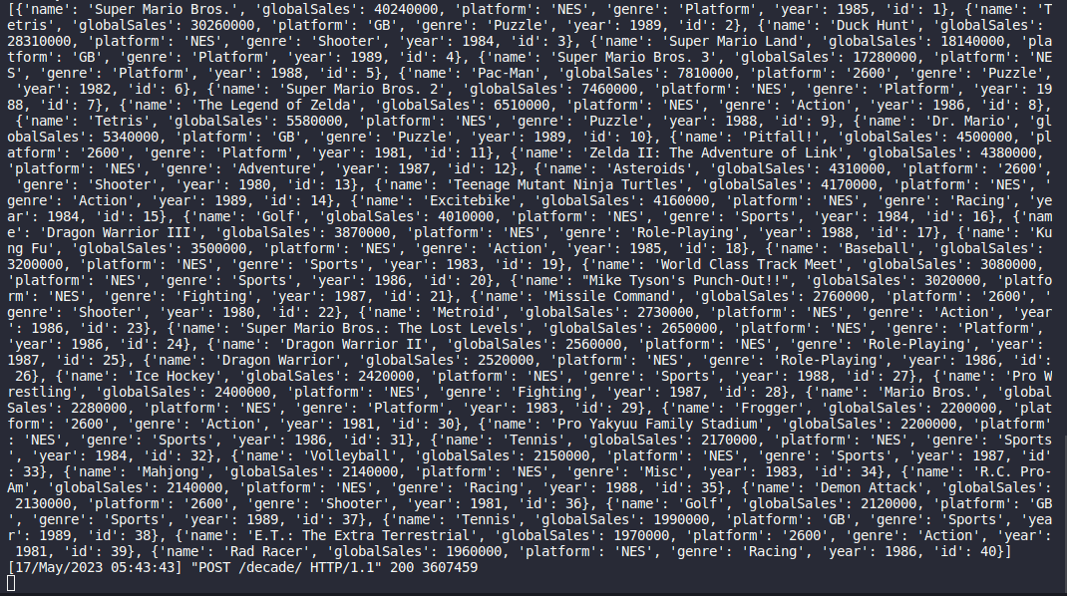
Queried data from the “80s” request – note that the ‘year’ attribute in each is between 1980 and 1989 and the ‘globalSales’ attribute is in decreasing order.
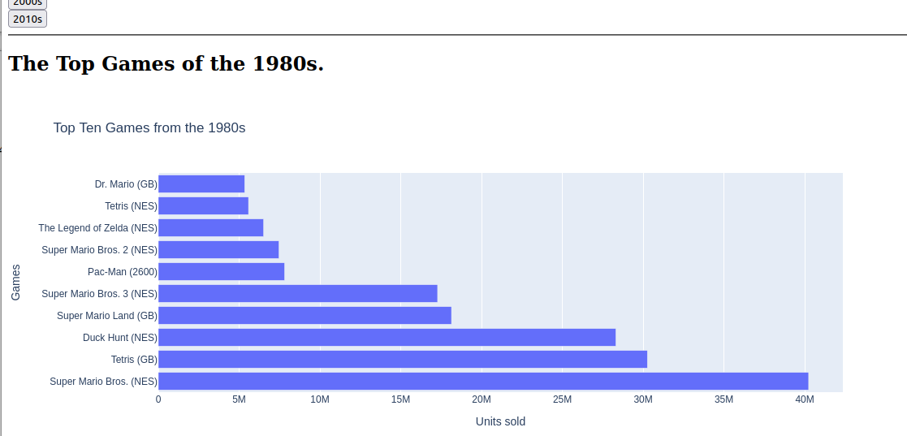
The top ten games from the 80s are consistent with the displayed data
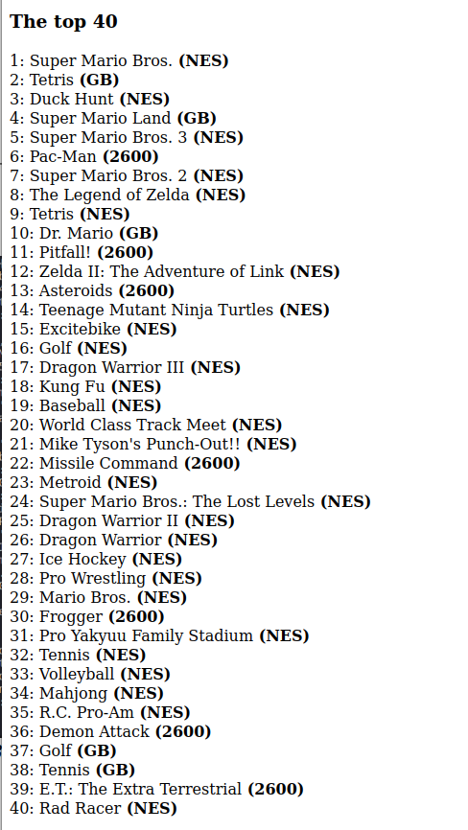
The top 40 list is in the same order as the printed data above

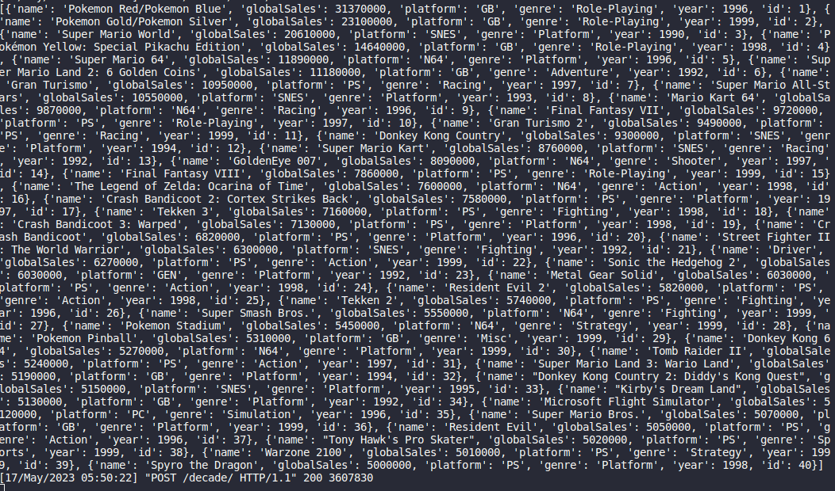
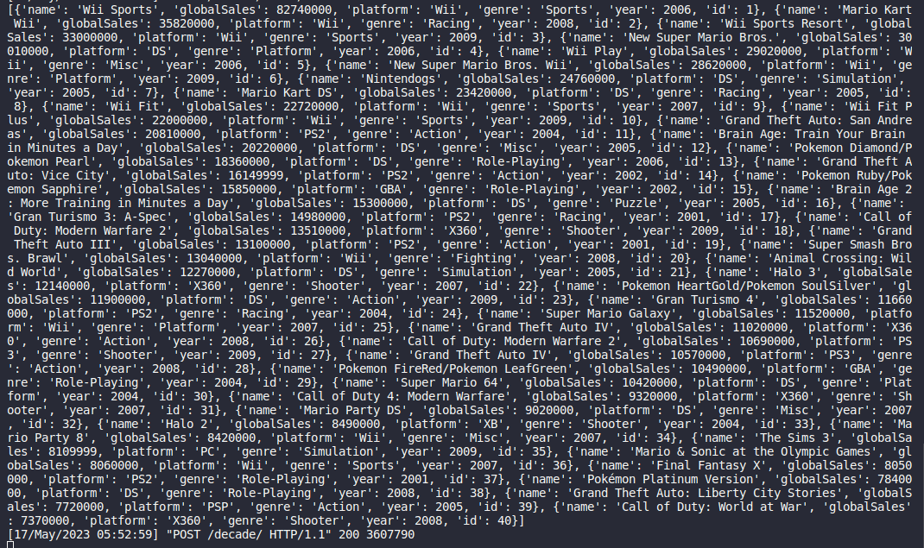
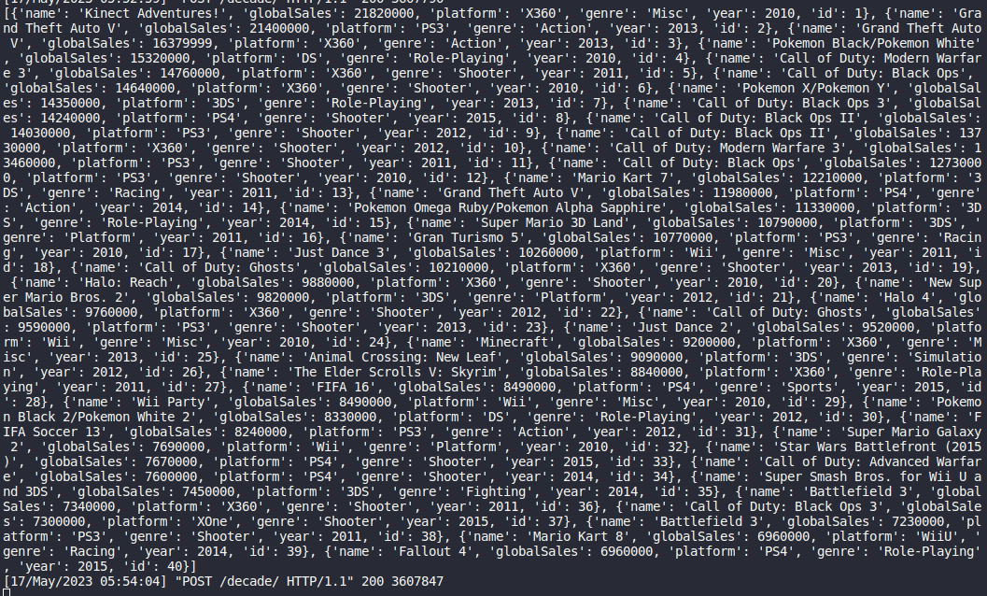
Data returned from the 90s, 2000s and 2010s all within the correct time frame and the sales are in decreasing order

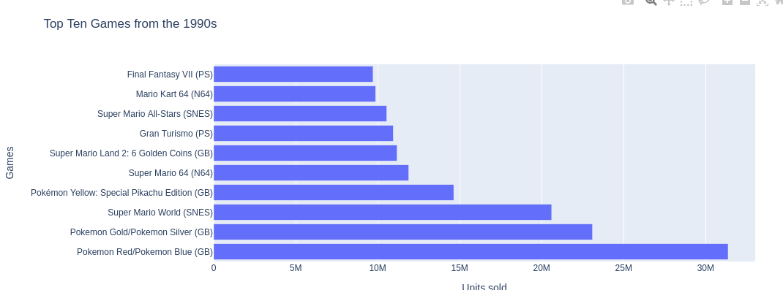
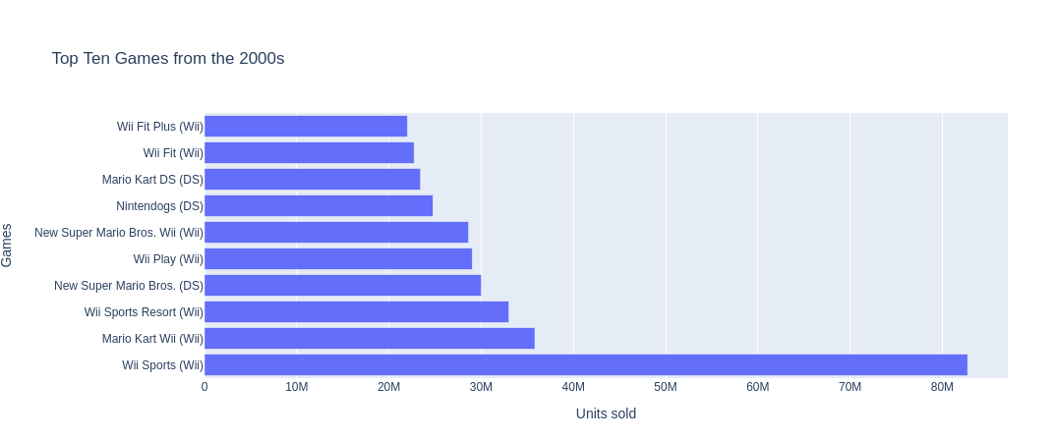
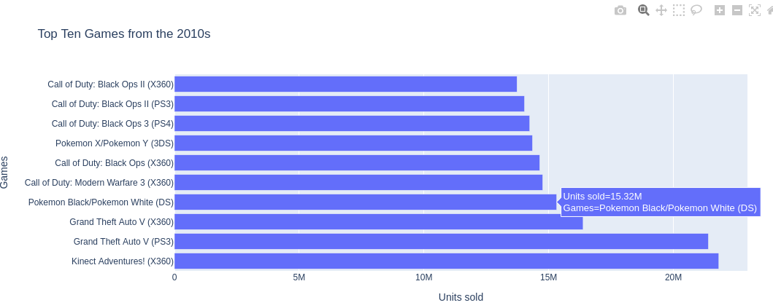
All of the top 10 lists are consistent with the returned datasets

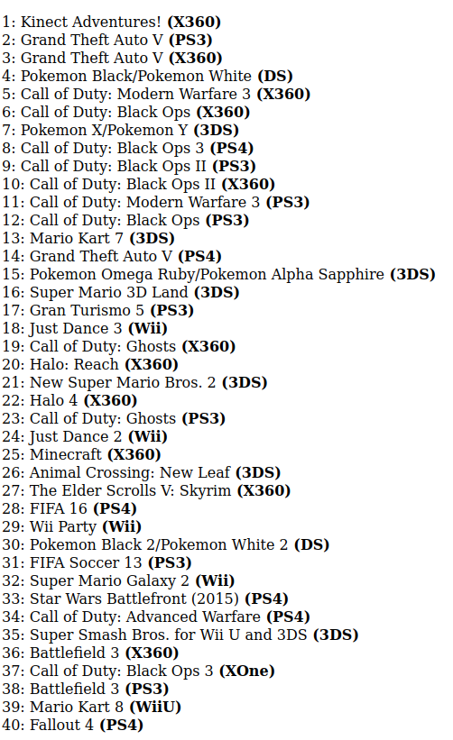
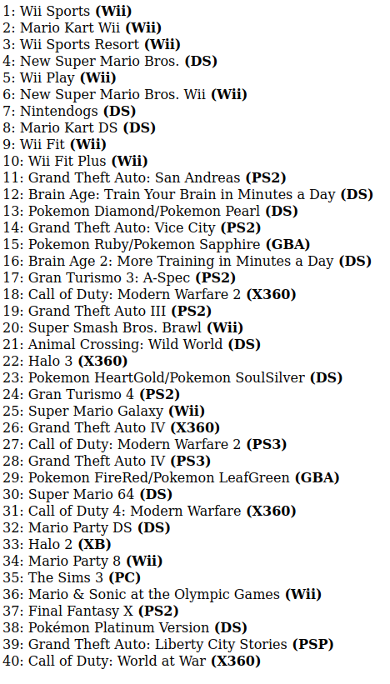
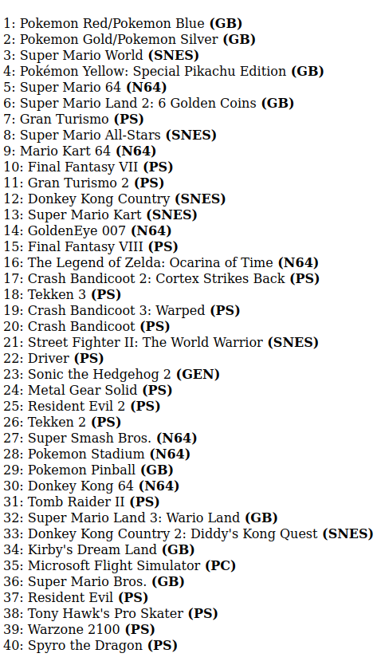
the top 40 lists are all consistent with their corresponding datasets

The above process was repeated with the “top100”, “consoles” and “year” pages all reporting consistent data.

15/05/23
Static files – Static files were configured for the CSS files and images that will make the application much more approachable to users.

CSS and Javascript – JS and CSS enable for the pages to be much more user friendly. The CSS makes controls the style of the pages and the Javascript was primarily used on the “top 40” lists to stack them as two columns. The screen shots below show before and after images of each page on the web application.

Index page
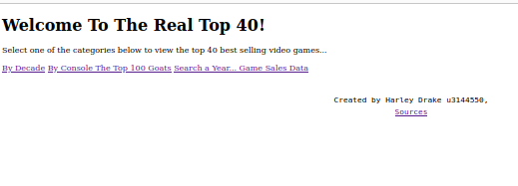

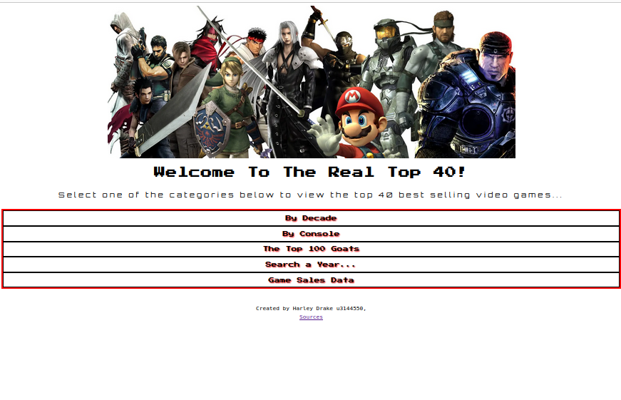

Decade Page

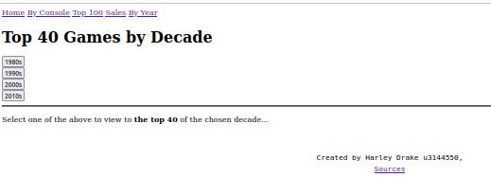

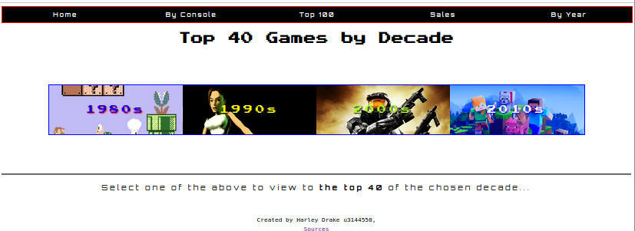

Console Page
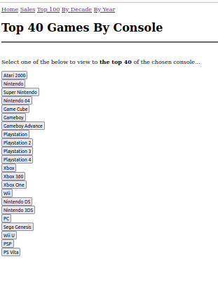
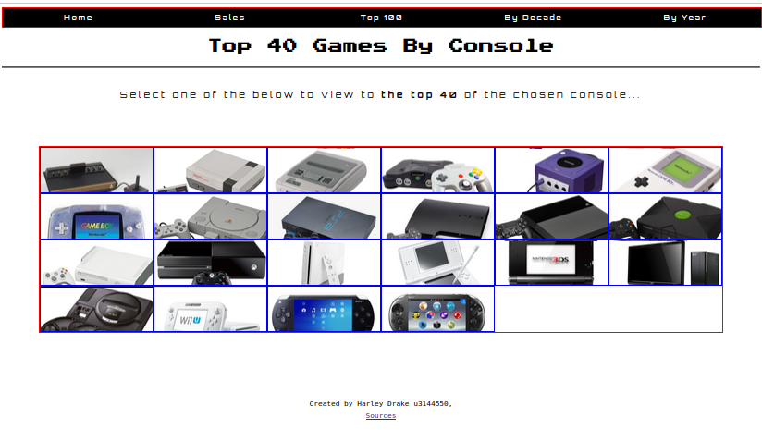
Top 100 page
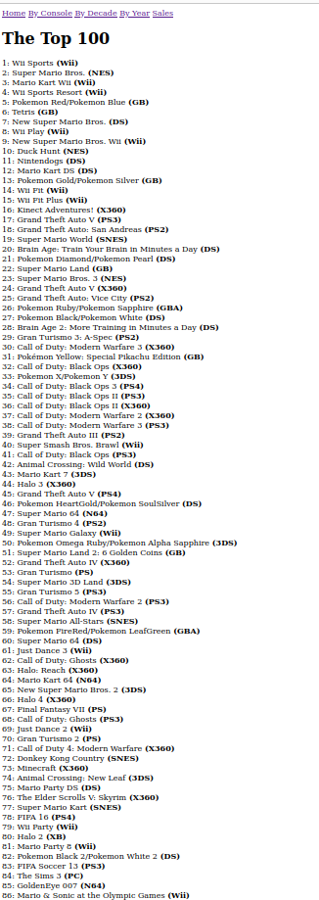
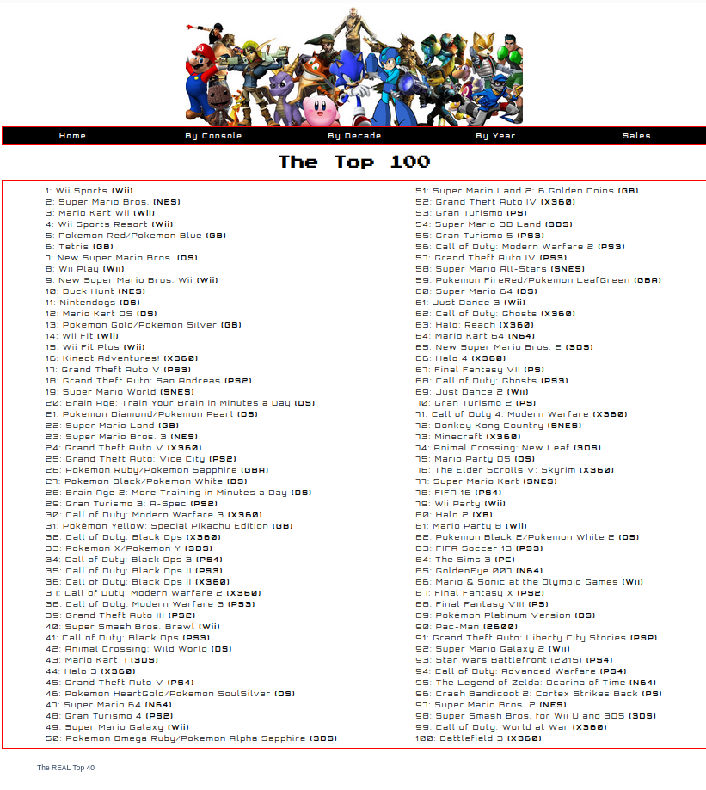
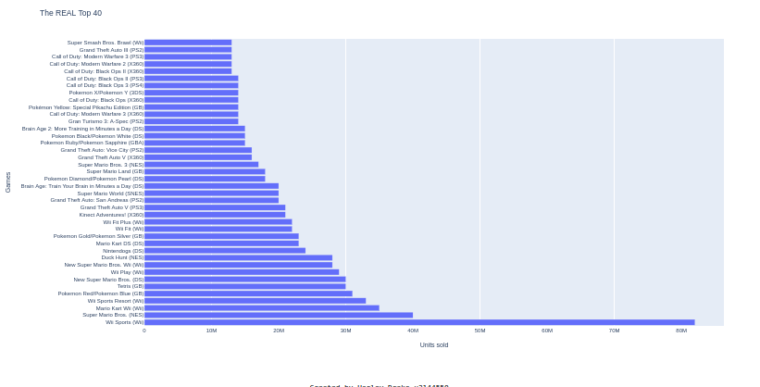
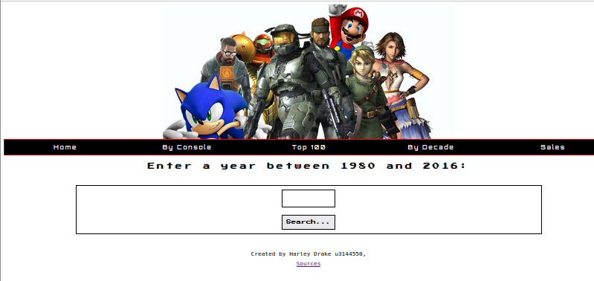
Year page

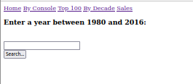

All images are referenced at the end of this report.

16/05/23

Sales page – The final feature of the web application is a report of the total unit sales in each region from the year 1980 to 2010. The first requirement was to set up a dictionary object that contained every year from 1980 to 2010 as the keys and nested dictionaries each reporting the sales in North America, Europe, Japan, Other region and Global sales, all set to 0 initially (as shown below).
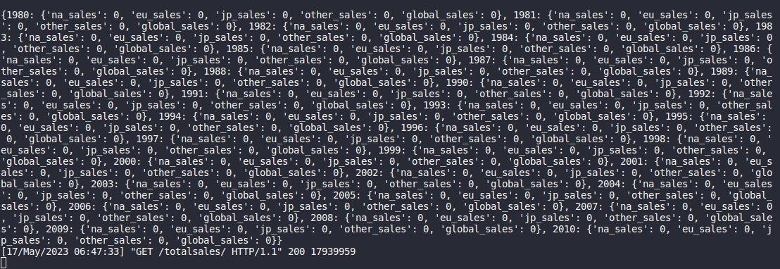
The next task is to iterate over every entity (game) in the database and add their category sales into their corresponding years. There are a number of entities in the database that do not contain a year entry so there is a condition in the code that states that the year must be between 1980 and 2010, entries with no year are saved a “0” in the database which is safely outside the required range.

The resultant updated dictionary is shown below, this is after ever element is iterated over and their sales data are added.

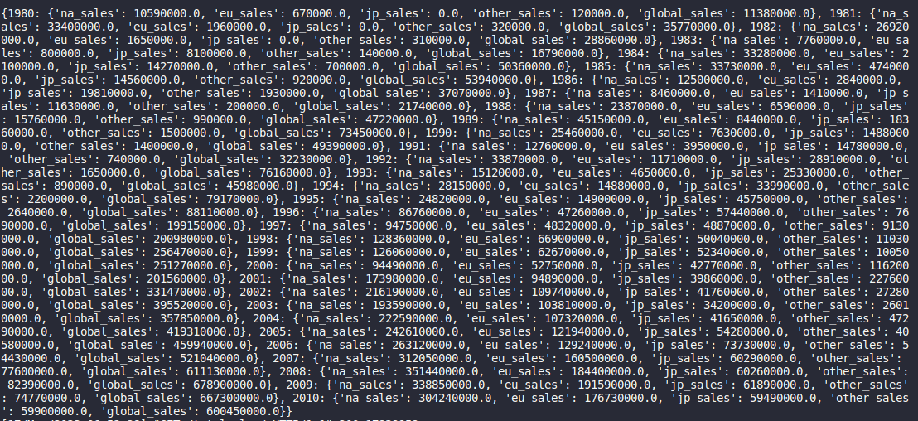
This dictionary is returned and each data list is extracted as x values (years) and y values (NA, EU, JP, other and global sales) for 5 different scatter plots. These 5 scatter plots are then created from Plotly and then embedded into the “totalSales.html” template. CSS was then added and the page is complete.

17/05/23

3rd party testing – Allowed a sample of users to test the web application.

